**LARAVEL MVC CRUD**

www. Req.

Route

DB

Controller

View

Model

GUI

Data

PHP and Composer installed on your local machine,

<https://laravel.com/docs/12.x> visit site and copy create command

composer create-project laravel/laravel crud1

files and folder for laravel created and then type give below

htdoc>repo>php artisan serve

(start php xamp controlpanel start apache; Mysql, if apache not start then goto>http.config > search listen 8080 replace 8000)

Chrome-> 127.0.0.1:8000 -> welcome.blade.php

Database

Create database manually

Goto>.env file>change database connection = mysql; database=name

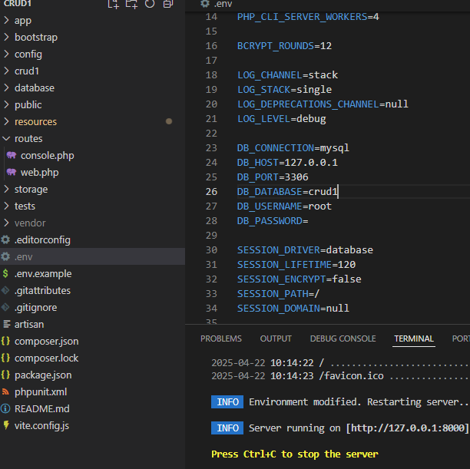

To check connection

>php artisan migrate

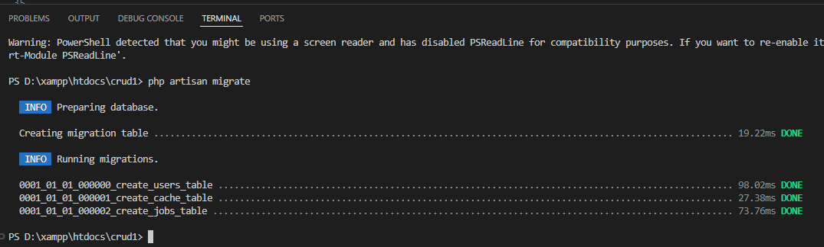

Default tables created

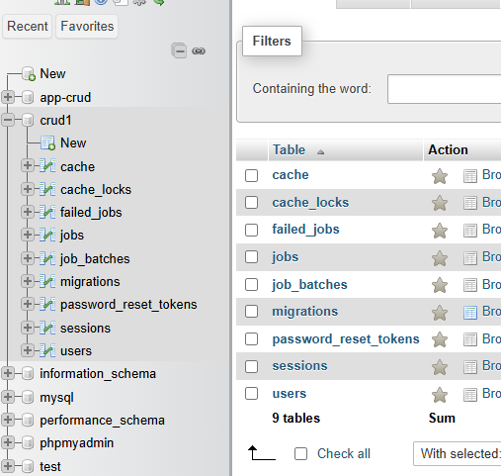

**Create Table**

Migration creation-> to create table

>php artisan make:migration create_names_table

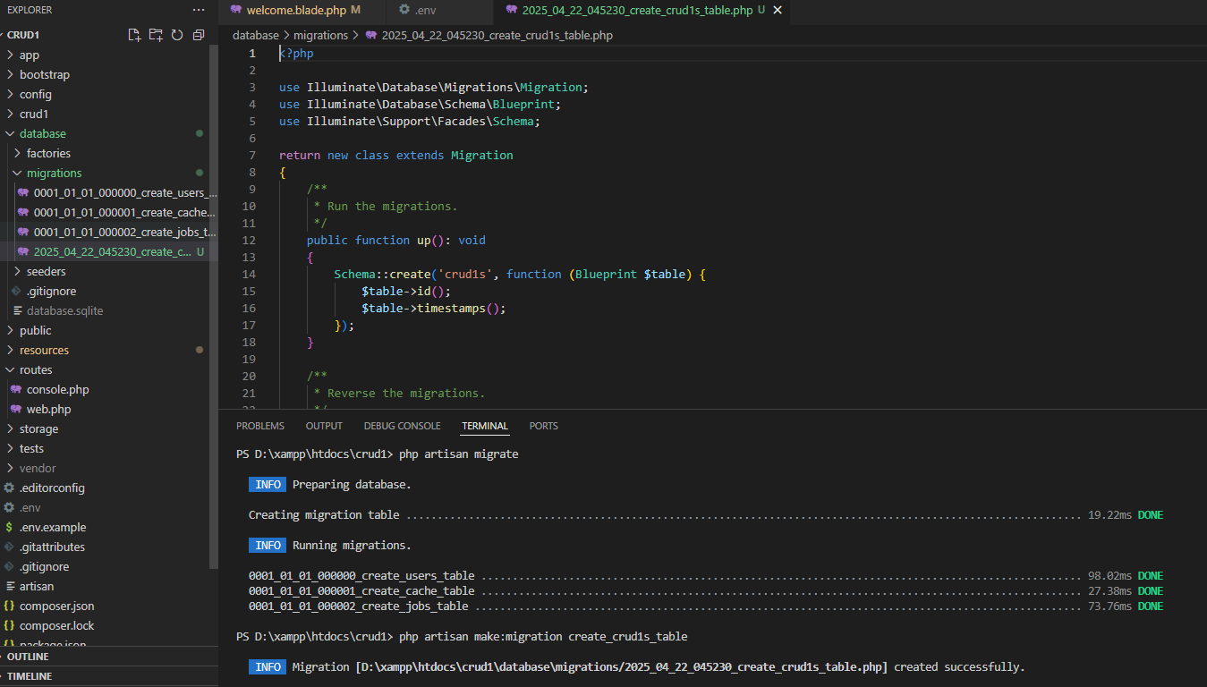

**Create column in table** -> database>migrations> 2025_04_22_045230_create_crud1s_table.php

 public function up(): void

    {

        Schema::create('crud1s', function (Blueprint $table) {

            $table->id();

            $table->string('name');

            $table->string('dob');

            $table->string('address');

            $table->string('email');

            $table->string('mobile');

            $table->timestamps();

        });

Search on laravel site> migration > <https://laravel.com/docs/12.x/migrations#main-content>

Available data types for more

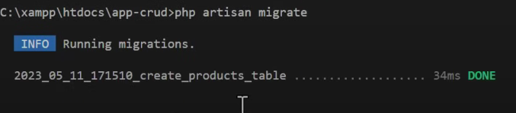

Php artisan migrate ( to create table)

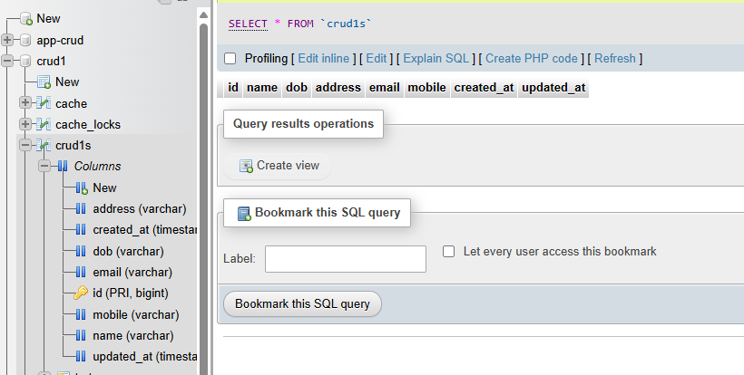

**Model**

<https://laravel.com/docs/12.x/eloquent>

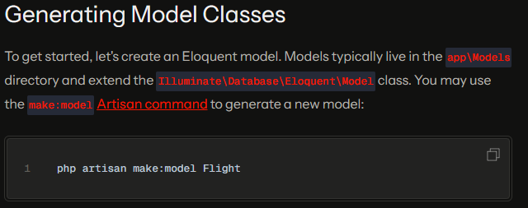

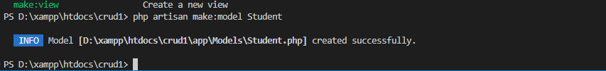

App>Models> Students

Put column name to fill

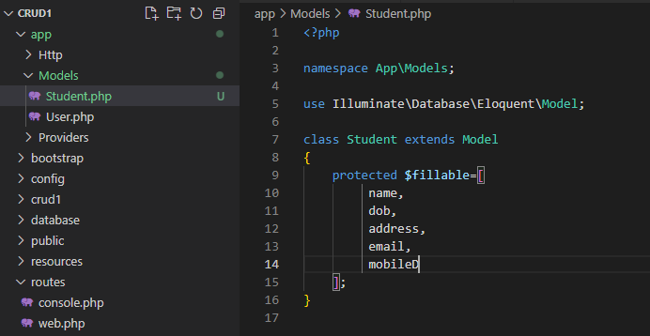

**Controller**

Search controller in doc.

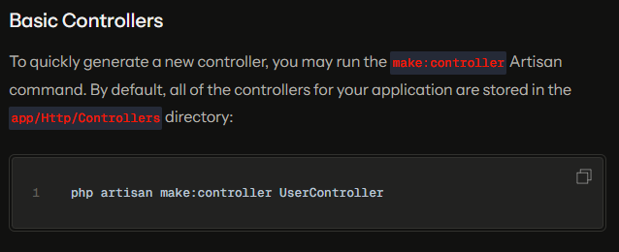



App>http>controller>StudnetController

**Now need to create view**

Create view>mkdir students folder

App>resources>View>students> index.blade.php create index.blade.php file

Now create Route to view/index goto App>routes>web.php



url text=> ‘/student’

controller class=> [StudentController::class

function =>

any name ->name()

Now goto controller and create a function to route

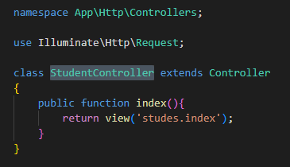

In web.php> use App\Http\Controllers\StudentController (import controller to web.php to show index)

